**OpcDaCom settings:**

**Change of Tolerance**

1. Open Database from the OpcDaCom application window:
   1. 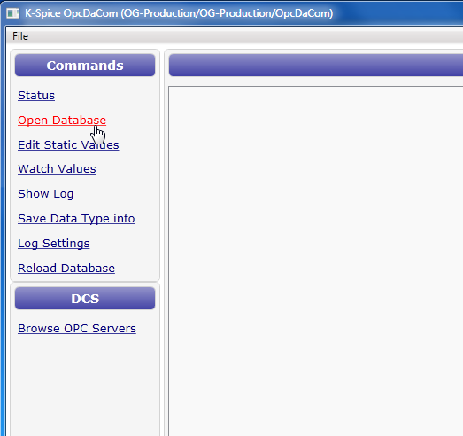
2. Open Query “KsimIoList”
   1. 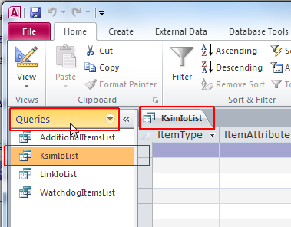
3. Scroll to the right and change the “Tolerance” to 0
   1. 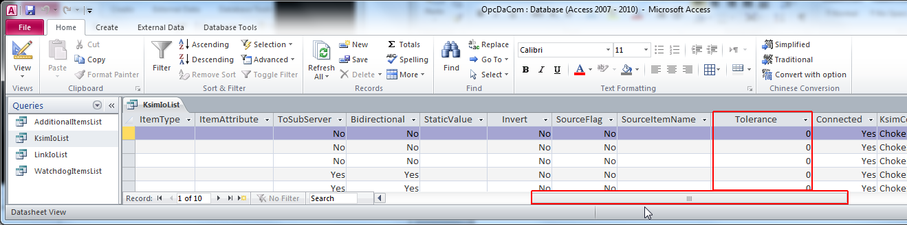
4. Close MS Access and “Reload Database” from OpcDaCom
   1. 